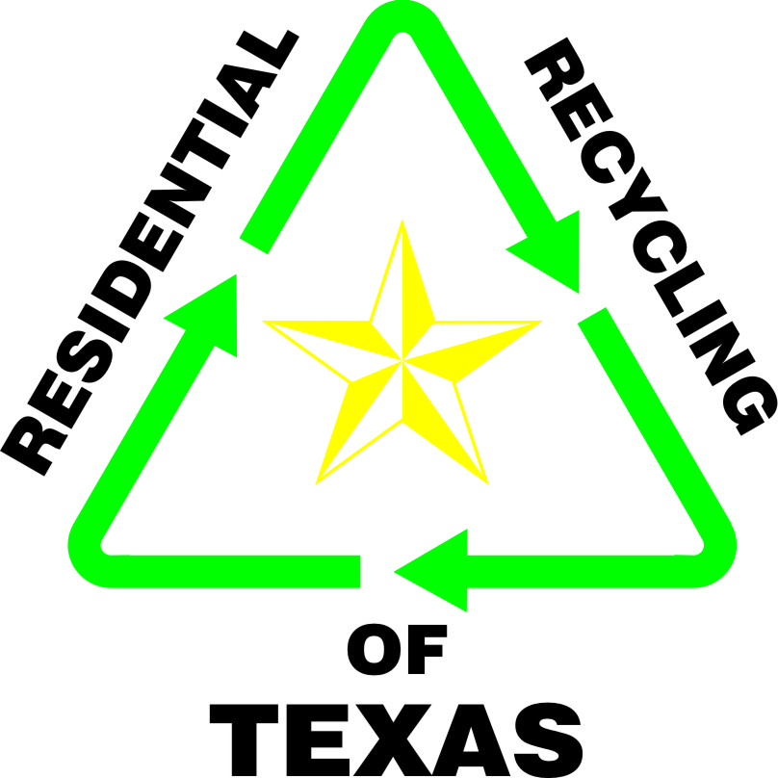^{Recycling Program Information}
^{General Information}
To order a recycling bin, call 1-866-516-9805 (toll free).
Regular pickup day is every Friday
Recycling Emblem sticker available if you are using your own container
Holidays: New Year’s Day, Memorial Day, July 4th, Labor Day, Thanksgiving, & Christmas
^{Tips That Help}
- On windy days – put any paper or light weight items that might blow away in a trash bag (clear, white or blue – no black please) just set next to bin
- No need to separate items – everything can go in the bin together
- Please leave lids off plastic containers (helps them compress better in the truck) – the lid can still go in the bin
- Please breakdown any larger size cardboard boxes and just set it under or beside the bin
- Please rinse out all containers – the residue from product can contaminate the load
- All plastics that are recyclable will have a triangle on the bottom with a number in the middle – we take #1 - # 7 (only exception is Styrofoam)
- Excess items can be put in a trash bag (clear, white or blue – no black please) or in any type container - just mark them as “recycling”
- We can send Recycling Emblem Stickers to you if you have larger containers (even trash cans) you want to make into a recycling container
- Trash and recycling pickup on the same day? – it really helps if trash is on one side of the driveway and recycling on the other side of the driveway
- So Sorry – but we don’t take any type of Styrofoam products (peanuts, blocks, sheets, etc)

Items RRT Can Accept for Pickup
PAPER
- Newspaper, magazines, catalogs, annual reports, paperback books, junk mail
- Clean pizza boxes, soda and beer boxes
- White/Colored/Fax paper
- Telephone books, paper egg cartons
- Carbonless forms, tissue/paper towel roll cores
- Shredded paper strips
Cardboard
- Corrugated cardboard boxes
- Cereal, food, detergent, pet food type boxes
- Milk/Juice paperboard cartons
- Slick-coated Frozen food boxes
Glass
(All colors are accepted – remove lids)
- Wine, coke, beer bottles
- Food jars
Metal
- Soda, juice, and beer aluminum cans
- Tin/Steel food and pet food cans
- Aluminum foil, disposable pie pans and trays
- Metal jar lids
Plastic Containers #1-7 (see other side for code descriptions)

- Milk, juice, and cooking oil jugs or cartons
- Fresh Vegetable/Fruit containers
- Soda/Water Bottles
- Dish Soap, Shampoo, Lotion, Soap Bottles
- Bleach/Detergent containers
- Household cleaning containers
- Butter/Ice Cream tubs/ yogurt cups/ microwave trays
- Clean plastic flower pots
- Prescription pill bottles
- Grocery store bags, dry cleaning bags, produce bags, plastic sleeve from newspapers
- Styrofoam

Items RRT Cannot Accept

PAPER
- Disposable Diapers
- Food-encrusted pizza boxes
- Cereal box liners, deed/seed bags
- Photographs, foil greeting cards
- Tissue paper, foil gift wrap
- Hardback books, Tyvek envelopes
- Used Paper plates, cups, and napkins
- Air-condition filters
- Fireworks

Metal
- Paint and aerosol containers
- Pesticide and chemical containers
- Oil filters and batteries
- Syringes, needles, and sharps
- Knives
- Wire Hangers

Plastic Containers
- Film wrap
- Anti-freeze & Motor oil containers
- Pesticide and chemical containers
- Plastic with no recycling emblem
- Prescription pill bottles with no emblem
- Toys, laundry baskets
- Unsanitary containers
- Electronics / Computer Parts

Glass
- Ceramics
- Pyrex
- Mirrors
- Light Bulbs

